Recommended Knowledge & Materials Resources

Prescriptions for A Healthy House by Paula Baker-LaPorte, et. al., 4th Edition
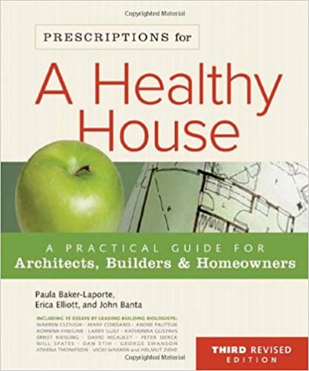

My Chemical-Free House
https://www.mychemicalfreehouse.net/
A guide to creating a chemical-free, VOC-free, mold-free house

Building Biology Institute
https://buildingbiologyinstitute.org/
Articles, videos, downloads, podcasts, fact sheets

475 High Performance Building Supply
www.475.Supply
Based on building science, sustainable material use, Passive House, low carbon
Knowledge Resources: On-Demand Courses, CAD downloads, Smart Enclosure Wall Sections, etc.

Green Building Supply
https://www.greenbuildingsupply.com/
“We help people create beautiful, healthier homes by delivering high performance, eco-friendly products we have personally tested.”

